ICE APPLE - Components

User Manual

Revision History
Date | Version | Description | Author
03/09/2016 | 1.0 | Initial draft | Shekhar  Sathish

Table of Contents

1. ICE Apple components 3
1.1 Popup core: 3
1.2 Menu Core 8
1.2.1 GUI 9
1.2.2 GUI - Properties 10
1.2.3 Description of Menu Properties 13
1.2.4 Core/Menu Item Configuration 14
1.2.5 Menu Button to Action Map 28
1.2.6 Sample Menu configuration 30
1.3 Message Core 37
1.4 Language Core 38
1.5 Animation Core 39
1.6 View Manager 39

ICE Apple components

- Animation core
- Popup core
- Message core
- Menu core
- Language core
- View Manager

Popup core:

To display popups from various modules. Decides which popup need to be displayed among all the active popups based on the configuration done in Popup Configurator Tool.
Key Responsibilities
  - Maintain the screen display time
  - Prioritize the screen within a layer
  - Same priority popup are grouped and queued as LIFO queue,
  - Button event to Remove a screen, keypad data collection (like phone number, cd track entry etc), and Progress bar management of screens.

Popup Core Application path:
..\ui.core.iceapple.doc\popup.core.02\Popup_Configurator\Popup_configurator.exe
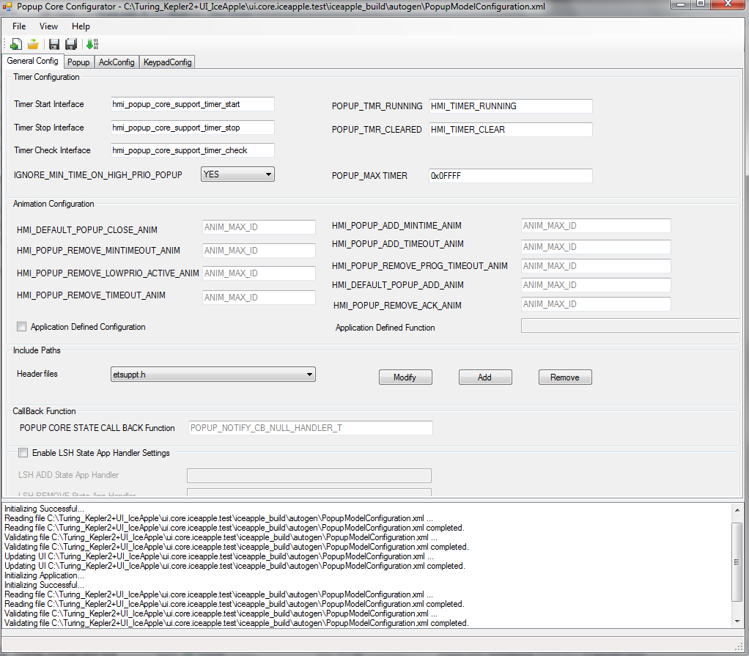

File->
New: To create New Popup configuration (.xml)
Open: Open existing Project (.xml)
Path for XML:
..\..\ui.core.iceapple.test\iceapple_build\autogen

Save: Save Project at specified path

Generate Files:
Select checklist as if required and make sure the below files to be generated after successful code generation.
hmi_popup_core_if.c
hmi_popup_core_if.h
hmi_popupcore_readme.txt
hmi_popup_core.dat

Types of Popup Configuration
- General Config
- popup Config
- Ack Config
- Keypad Config

General Config:
Timer Configuration: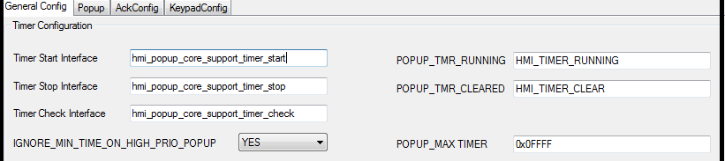
Timer Start Interface:
hmi_popup_core_support_timer_start (): - Start timer interface
-> This function used for creates a timer with the specified time-out value.
Timer Stop Interface
hmi_popup_core_support_timer_stop ():- Stop timer interface
-> Destroys the specified timer.
Timer Check Interface
Check timer interface weather Time is running or not (i.e. HMI_TIMER_RUNNING)
Specified macros are using for Timer configuration
POPUP_TMR_RUNNING
POPUP_TMR_CLEARED
POPUP_MAX_CLEARED
IGNORE_MIN_TIME_ON_HIGH_PRIO_POPUP

- Animation Configuration

If any specific animation types are used by using GDT .Corresponding handler will be used
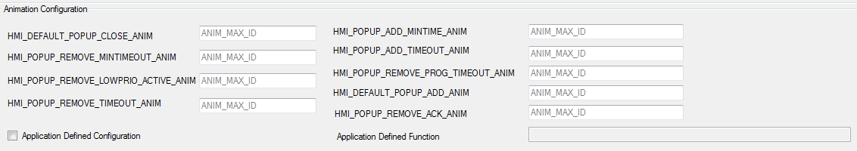

If not used animation set ANIM_MAX_ID

- Application Defined Configuration
- Application Defined Function

- Include Paths
- Header Files : add header file
- Call Back Functions
POPUP CORE STATE CALL BACK FUNCTION
- Enable LSH State App Handler Settings
LSH ADD State App Handler: Add screen add function
LSH REMOVE State App Handler: REMOVE screen add function

Popup Config:

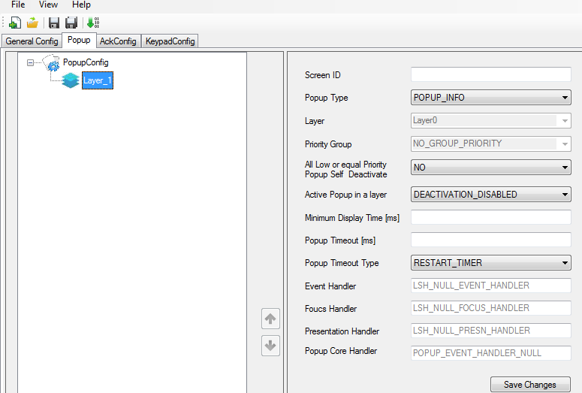

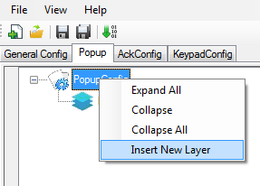

1. Insert New Layer: To create New layer for designing the popup

Screen ID: Enter the View Manager Screen ID of the popup

Popup Type:
POPUP_INFO

The info popup are just the information popup that are put up in the display just to
Inform the user.

POPUP_PROGRESS
Additional to info popup characteristic, progress bar popup shows the status or the
Percentage complete or a time bar to the user. The developer has to configure the
Progress rate of popup in the configurator tool.

POPUP_ACK
Additional to info popup characteristics, acknowledge popup displays information to
the user as the information popup but waits for a user acknowledgement. The
Developer has to configure an acknowledge event in the configurator tool.

POPUP_KEYPAD

Find Help- contents -> Info and All Popups for brief information about screen properties

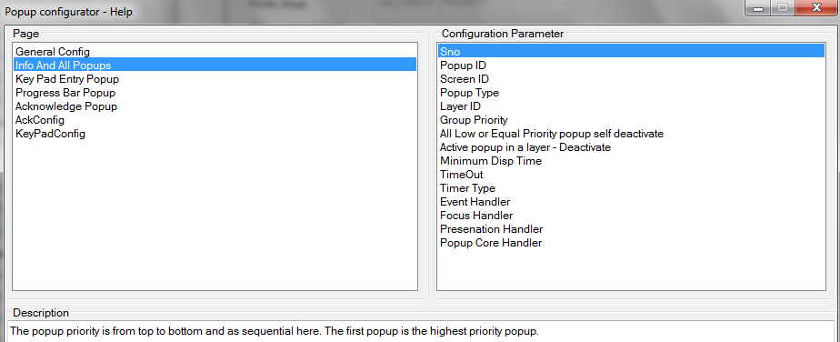

Ack Config:

Add Config Name: Specify user defined
Button Events: Add required events
Button Type:
Popup Config Type:

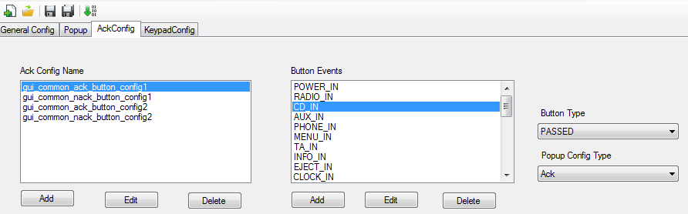

Refer help- contents->Ack Config

Keypad Config

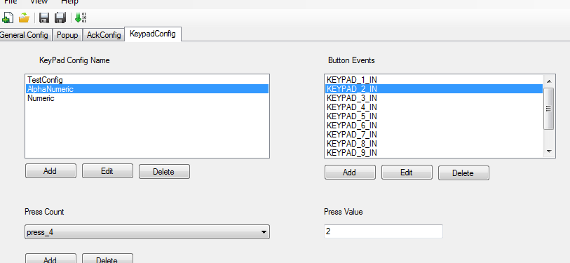
Refer help- contents->Ack Config

Menu Core

MENU CORE is considered as the backbone for “display structuring and building”. Menu core possesses the general Menu functionalities acted upon by the predefined configuration and it provides a common place for handling the General Menu functionality by categorizing the Menus of various types.
Menu functionalities:
Menu Open
Menu close
Menu Button action (up, down, left, right, ok)
Menu fast scroll
Menu Rebuild
Menu Reload
Menu Dynamic
The Button Inputs and certain commands from the application shall trigger the Menu Core to function and it invokes the specific component to perform action and finally the Display is updated.

Application (Menu core configurator Tool) in workspace Path:
..\ ui.core.iceapple.doc\menu.core.01\menu_configurator_tool.exe
Menu core configurator Tool: menu_configurator_tool.exe
The lite version of Menu core configuration for Newton2.0 platform only.
..\ui.core.iceapple.doc\menu.core.lite.01\menu_configurator_tool.exe
Note:
Latest menu core has not using the lite version

GUI

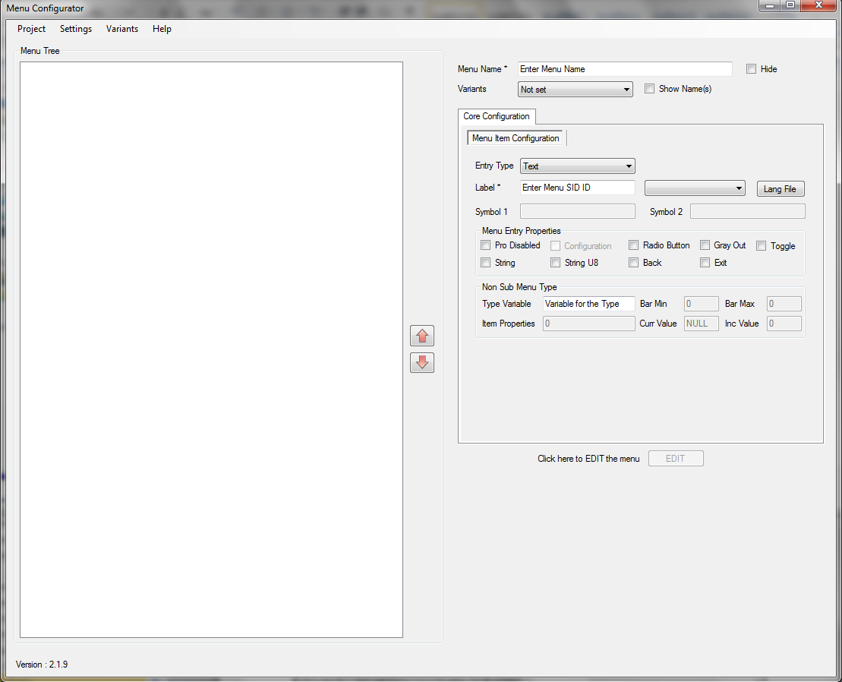

GUI - Properties

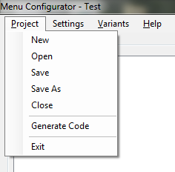
Project->New: To create new Menu configuration
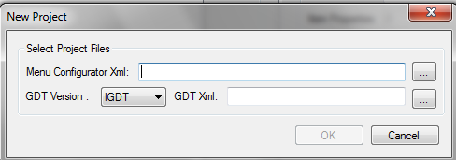

Menu Configuration Xml: Give the Proper name for Menu Configurator XML for newly creating.
GDT Version: Select GDT Version IGDT/1BPP/2BPP.
If selected Project (xml) i.e. GDT XML was designed by using IGDT then we have to select GDT Version IGDT
Similarly designed GDT XML by using 1BPP GDT -> GDT Version 1BPP and designed XML by using 2BPP GDT -> GDT Version 2BPP
GDT XML: Select Project xml which was designed by using GDT. It can be used for loading existing design only. If we want create new GDT xml by using GDT tool we can design.
Designed Xml available in the below workspace path:
..\..\ui.core.iceapple.test\iceapple_build\autogen\ MenuModelGDT.xml
Once you configured as mentioned above. Select ok button.

Open: To Load existing Project Settings
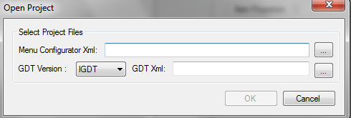
Menu Configuration Xml: Select the designed Xml available in the below workspace path:
.\..\ui.core.iceapple.test\iceapple_build\autogen\ MenuModelConfiguration.xml
GDT Xml: Select Project xml which was designed by using GDT. It can be used for loading existing design only. If we want create new GDT xml by using GDT tool we can design.
Designed Xml available in the below workspace path:
..\..\ui.core.iceapple.test\iceapple_build\autogen\ MenuModelGDT.xml
Once you configured as mentioned above. Select ok button. Configured Menu will be shown like the below screen.

Save and Save As: To store/save the designed project
Generate Code: To generate the code once menu configured. After generate code the below files will be generated

- hmi_menu_def_n.inc // Here ‘n’ represents the variant number.
This file contains Menu Definitions (Enums and #define statements).
- hmi_menu_config_n.inc
File contains Menu map actions table, MENU_ITEM_ENTRY_T and MENU_DEF_T entries.
If we have more than one variant, these files will be generated for all the variants

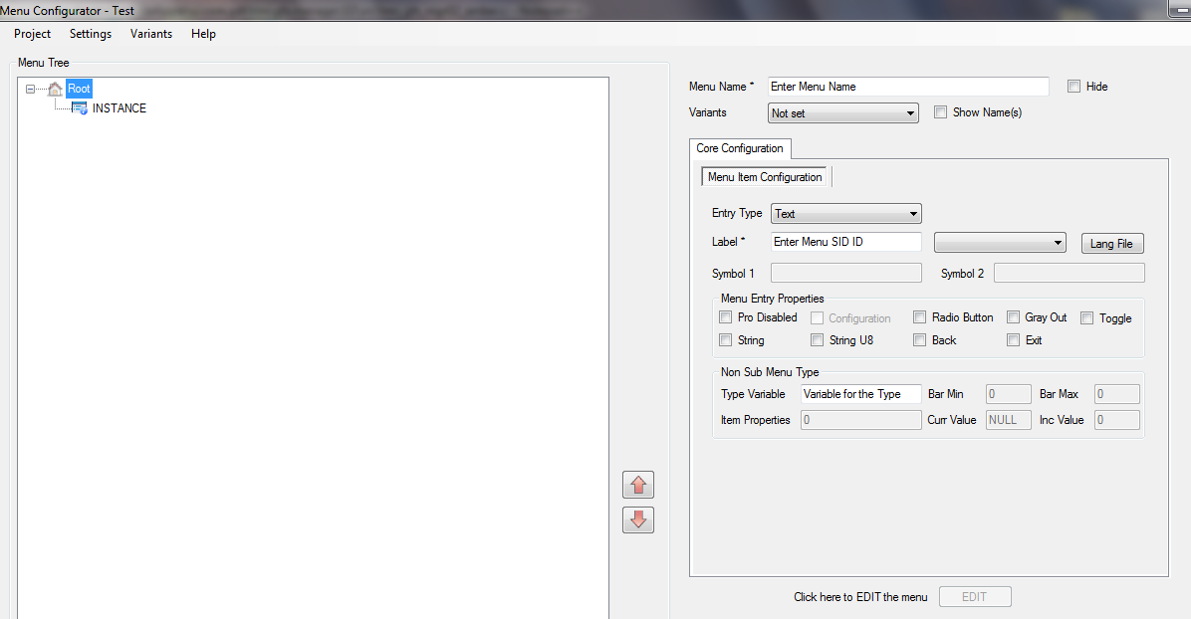

Right Click on Instance. It will show the properties list
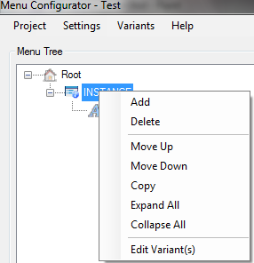

Add: To add new menu to the list
Move Up: To move one step upward direction in Menu Tree
Move Down: To move one step down ward direction in Menu Tree
Copy: Copy and paste the menu directly

Description of Menu Properties
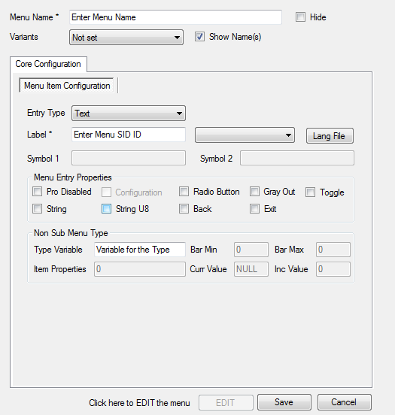

Menu Name: Give the Proper Menu Name
Hide: Hide the menu name
Variants:
By using this configuration, we can use the same configuration file for more than one variant. For e.g. If similar menu items are exist for more than one variant, we can configure all the menu entries as single project xml file and update the variant based on our requirement. So during code generation, code is generated for the particular variant. If we have 3 variant, then 3 set of files are generated. Each file contains menu entries which are specific to that variant. User can able to see the menu configuration for the given variant using ‘View specific’ option under Variants menu.
Show Name: To display the variant name as we configured in settings instead of Id

Core/Menu Item Configuration

Entry Type:
Specify the type of the menu. It can be any one of the following types
Text
Toggle
Bar Graph
Executable:
Sub Menu: Find the below screen for understanding

If we select Executable or Sub menu the screen will be shown like Menu configuration tab will be enabled.
Eg: Sub menu screen
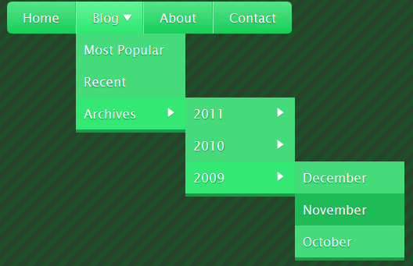
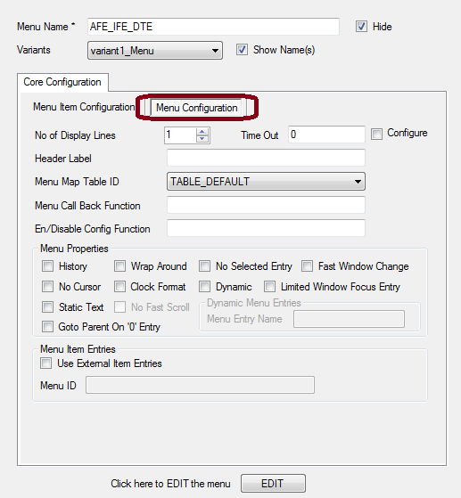
Label:
SID is referred as Label in the tool. This can be given by the user in the text box. Or it can be selected by a list of available SIDs which is in language_identifiers.h. When we select it from the language identifier file, it should have the following prefixes "t_" or "TxtID_". This is used to display the menu name dynamically.
Lang File: hmi_language_identifiers.h file which is generated using LanuageEncoder tool. The same file can select and after it will show the list of SID’s
Symbol 1&Symbol 2
Symbols are used to specify the icons for each menu. Number of icons can be 0, 1 or 2 which is configurable in the tool. This configuration is application specific. If the user sets the number of icons as 0/1, it assumes there is only one icon for all the menus. If its zero, by default all the symbols are filled with NULL value. For 1 and 2, user can enter the icon values from the GUI. If the number of icons is 2, then the following line will be included in hmi_menu_def.inc
#define HMI_MENU_ITEMS_WITH_TWO_ICONS
TOT_NO_OF_ICONS = 0/1 TOT_NO_OF_ICONS = 2
EntryType EntryType
Entry Properties Entry Properties
Symbol Symbol1
Symbol2
Label Label
Type Reference Type Reference

Menu Screen Id: GFX_SCR_MENU_TYPE_A this id of Screen which was designed by using GDT.
And the configured project xml selected initially. When we select the GDT xml load complete
Settings

Presentation Function:
Function to be defined here hmi_root_menu_present_cb() call back function. This is user define function and it handled the functionality of display the menu on the selected Menu screen.
Menu Entry Properties
Select the necessary below settings as per requirement.
Pro Disabled
Configuration: Used to configure the child items dynamically. This will be applicable only if 'Item Configuration' is enabled in application settings. Property Name - MENU_ITEM_PRO_CONFIGURABLE

Toggle: used for toggle settings
Back: Used to go to parent menu from the child menu using one button press. Property Name - MENU_ITEM_PRO_ACTION_BACK

Exit: Used to go to exit menu from the child menu using one button press. Property Name - MENU_ITEM_PRO_ACTION_EXIT

Non Sub Menu Type
Type Variable: Specify the variable name for the menu item. This is applicable for Text/Toggle/Bar Graph types
Bar Min: Specify the minimum value for barograph menu item
Bar Max: Specify the maximum value for barograph menu item
Curr Value: Used to store the current value for barograph menu item.
Inc Value: Specify the increment value for barograph menu item. It is used to navigate through barograph as additional steps.
Item Properties: N/A

Select the above settings as per requirement and generate the code. In generated code only we can see the results.
Menu type is Executable or Sub Menu
Menu Configuration:
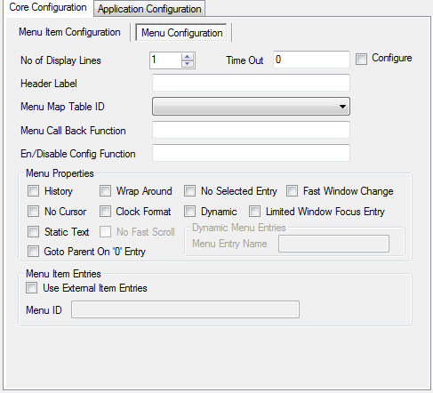
No of display lines: Describes the number of menu items should be displayed for current display.
Time out: Timeout value to close the menu automatically.
Configure: Decides whether timeout value should be configured or not.
Header Label: This is same as Label property for menu item. It can be used to specify different SID for sub menu. One is to display as menu item (Label).And another is to display as Header when we open the child items
Menu Map Table ID: Specify the table id for menu actions to button mapping. This table is generated using 'Menu Button to Action Map' option in settings menu
Menu Call Back functions: Specify the Callback function for the screen. hmi_root_menu_cb () its user defined function. Used for display the menu screen.
En/Disable Config function: Specify the Configuration function for the screen. hmi_root_menu_item_config_cb ().Its user defined function
Menu Properties
History: Used to maintain history for menu id and its focus entry. This property is enabled only when we enable History Handling macro in Settings menu. Property Name – MENU_PRO_HISTORY_MENU

Wrap around: Used to go to the first menu item when we do down action on the last menu item. Property Name - MENU_PRO_FOCUS_WRAPAROUND
No Selected Entry: This property is used to enable/disable selection marker for the menu item. Property Name - MENU_PRO_DISABLE_SELECTED_ENTRY

Fast window change: Used for page by page movement when we do down action on the last entry.MENU_PRO_NO_FAST_SCROLL should be enabled for this property. Both properties’ are mutually exclusive. Property Name - MENU_PRO_FAST_WINDOW_CHANGE

No Cursor: Used to disable the cursor for the current menu item. Property Name - MENU_PRO_DISABLE_CURSOR

Clock Format: Specify the menu type as clock format. Property Name - MENU_PRO_CLOCK_FORMAT

Dynamic: This property is used for dynamic menu configuration. If this is set to true, user has to enter the name of the dynamic menu entry array Property Name - MENU_PRO_DYNAMIC

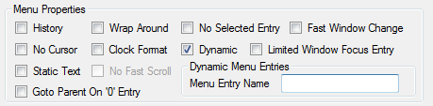

Limited Window Focus Entry: Added for Hyundai requirement where will not reach the end of the screen. Stops before last line. Property Name - MENU_PRO_LTD_WND_FOCUS_ENTRY

Static Text: Property Name - MENU_PRO_TXT_STATIC
No Fast Scroll: Used to enable/disable the fast scroll for the current menu. Property Name - MENU_PRO_NO_FAST_SCROLL

Dynamic Menu Entries Menu Entry Name
Go To parent on ‘\0’ Entry: Used to go to the parent menu when all the child items are inactive. Property Name - MENU_PRO_GOTO_PARENT_ON_ZERO_ENTRY

Menu Item Properties:
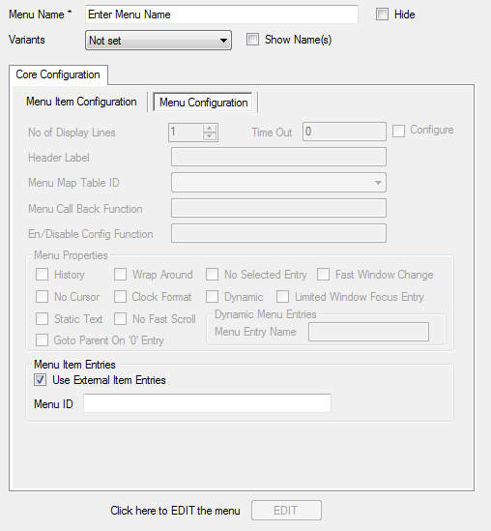
If we select the Menu Item Entries disabled all the Menu configuration properties. Please find the above screen.
Use External Item Entries
Menu ID:
- Add new menu item
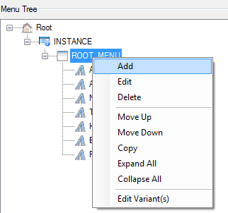
- 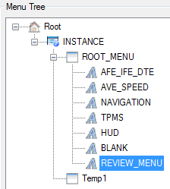
- Temp1 New Menu Added and do the setting as below
- 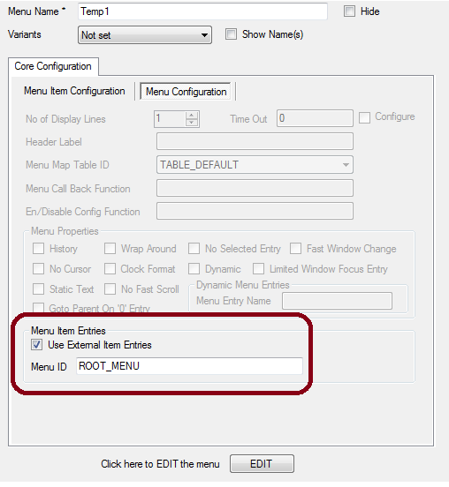

- So here when we want to access the ROOT_MENU (already designed) select the Temp_1 menu item. Externally accessing

Settings->Properties
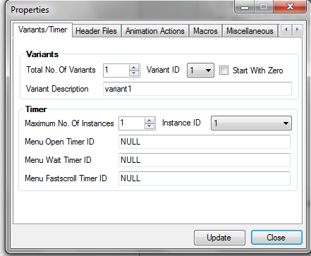

- Variants
For representing menus using these variants
Eg: Menu_1 -> Variant_1
Menu_2 -> Variant_2
Menu_3 -> Variant_2
We can map more than one menu’s to one variant. Otherwise we can create set of files for each menu.
And Refer Help->contents->Application settings->variants
And more about find the Variants section above

  - Total No of Variants : Select the no.of variants
  - Variant ID: It represents
  - Variant Descriptions: Mention the Purpose of menu

Start With Zero:
'Start with Zero' option can be used to change the variant ids as zero based indexes.
Refer the below example
If the user sets the number of variants as 2, following files will be generated

‘Start with Zero' enabled –
hmi_menu_config_0.inc, hmi_menu_def_0.inc,
hmi_menu_config_1.inc, hmi_menu_def_1.inc

'Start with Zero' disabled –
hmi_menu_config_1.inc, hmi_menu_def_1.inc,
hmi_menu_config_2.inc, hmi_menu_def_2.inc
Timer:
It decides the maximum number of instances supported by menu core. For each instance we need to specify the following values which is unique in the given menu instance
        - Open Timer ID
        - Wait Timer ID
        - Fast Scroll Timer ID

And also we can disable animation and fast scroll using the following properties
Disable Animation
Disable Fast Scroll

Maximum No.of Instances: if we have 2 instances. It represents sub menu items along with main menu .i .e Main Menu and sub Menu are active. Please see the below screen.
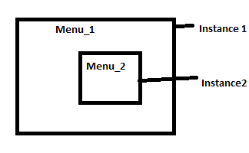

Header Files
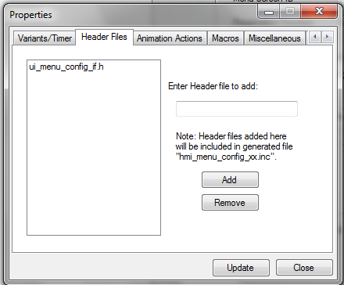
Header files which need to be included for the project can be added from the UI

Animation Actions
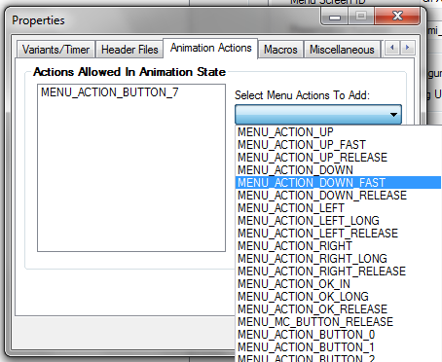
Used to handle menu action in animation state. To configure animation settings while navigating from one menu item to another menu item. What type of animation actions are allowed then we have to add and if not required remove.

Macros
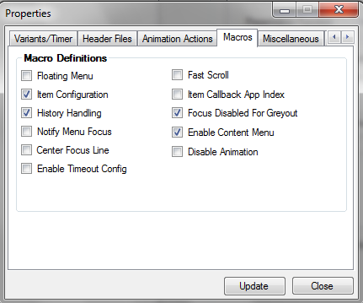
As per requirement select the macros and update then generate the code. Ensure selected macros will be visible

Floating Menu: Used to add the menu item dynamically this is not configured through Menu Configurator tool. Macro name in hmi_menu_def.inc - 'HMI_MENU_FLOATING_MENU_FEATURE'

Item Configuration: Used to show/hide menu items dynamically based on application configuration. Macro name in hmi_menu_def.inc - 'HMI_MENU_ITEM_CONFIG_FEATURE'

History Handling: This macro used for maintaining history for menu id and its focus entry. Macro name in hmi_menu_def.inc - 'HMI_MENU_HISTORY_HANDLING_FEATURE'

Notify Focus Menu: Used to send the menu focus status to the application whenever the focus changes. Macro name in hmi_menu_def.inc - 'HMI_MENU_CORE_NOTIFY_MENU_FOCUS'

Center Focus Line: Used for center focus line handling while opening the Menu
Macro name in hmi_menu_def.inc - 'HMI_MENU_CORE_CENTRE_FOCUS_LINE'

Enable Timeout config: Used to specify the menu timeout dynamically from application.
Macro name in hmi_menu_def.inc - 'HMI_MENU_TIMEOUT_CONGIF_FEATURE_ENABLE'

Fast Scroll: Enables 'Fast scroll' functionality. Macro name in hmi_menu_def.inc - 'HMI_MENU_FAST_SCROLL_ENABLE'

Item Callback App Index: Used to provide option for additional parameter which will be used in config callbacks. Macro name in hmi_menu_def.inc - 'HMI_MENU_ITEM_CONFIG_WITH_APP_INDEX_FEATURE'

Focus Disabled for Greyout: Macro name in hmi_menu_def.inc - 'HMI_MENU_CORE_FOCUS_DISABLED_FOR_GREYOUT'

Enable content Menu: Used to support for separate Closing and Opening animations during Menu traversal. For Up, down, left and right, both remove and add screens will be requested from menu core. This will be applicable only if the number of displayed lines is one. If we enable this, we need to give individual presentation handler and screen id for each menu item. Macro name in hmi_menu_def.inc - 'HMI_MENU_CORE_CONTENT_MENU_ENABLED'

Disable Animation: There is no macro generated for this property. This option is used to get the input for menu_wait_timer_id used in MENU_INST_CONFIG_T table. 'menu_wait_timer_id' is applicable only when animation enabled. 'Disable Animation' should be updated based on 'LSH_ANIMATION_SUPPORT_ENABLED' macro which is defined in logic_state_handler.cfg

Miscellaneous:

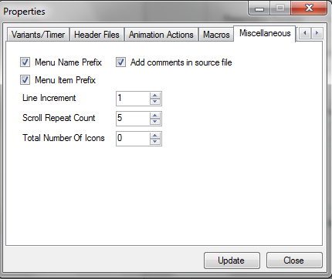

Menu Name Prefix: Option to add submenu/exe name as prefix for MENU_ITEMS enumeration. By default all the menu items are prefixed by menu name and MENU_ITEM

Menu Item Prefix: Option to add MENU_ITEM as prefix for MENU_ITEM enumeration. By default all the menu items are prefixed by menu name and MENU_ITEM

Add comments in source file: Option to add the comments for the MENU_DEF_T and MENU_ITEM_ENTRY_T structure members in the generated code.

Line Increment: It is used for the focus line position and marker display. Usually '1' would be set. But for the Bar graph Menu type according to display lines it can be configured. Example: In MFD LOW version, for Bargraph Menu the focus line and the marker increments by two.

Scroll Repeat count: Describes the number of scroll count before starting Fast scroll

Total Number of Icons: Symbols are used to specify the icons for each menu. Number of icons can be 0, 1 or 2. This configuration is application specific. If the user sets the number of icons as 0/1, it assumes there is only one icon for all the menus. If its zero, by default all the symbols are filled with NULL value. For 1 and 2, user can enter the icon values from the GUI.'HMI_MENU_ITEMS_WITH_TWO_ICONS' macro will be generated if user sets the number of icons as 2. 'MENU_ITEM_ENTRY_T->item_symbol2' member will be added based on this macro.

Application Properties:
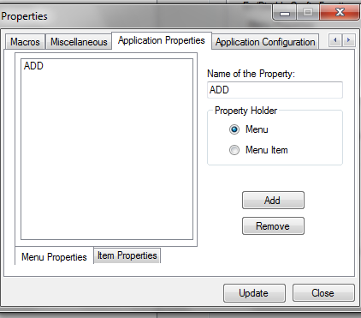
Used to configure application specific property. Application team if they want additional settings uses these settings. These properties are added in MENU_APP_DEF_T and MENU_APP_ITEM_ENTRY_T structure which is defined in hmi_menu_app_types.h

Application Configuration:
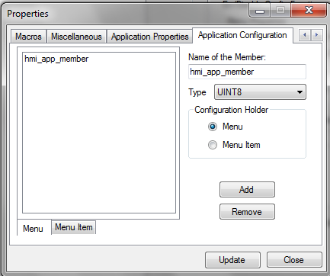
Used to configure application specific configuration for sub menu and menu items. These members are generated as separate data structure MENU_APP_DEF_T and MENU_APP_ITEM_ENTRY_T in 'hmi_menu_core_01_app_types.h' file these properties are added in separate file hmi_menu_app_types.h. The same file will be generated along with code generation files.

After Adding/configuring as above the screen will be seems like below
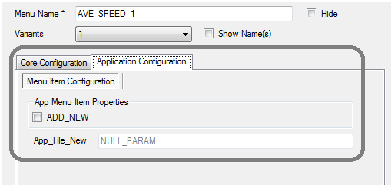

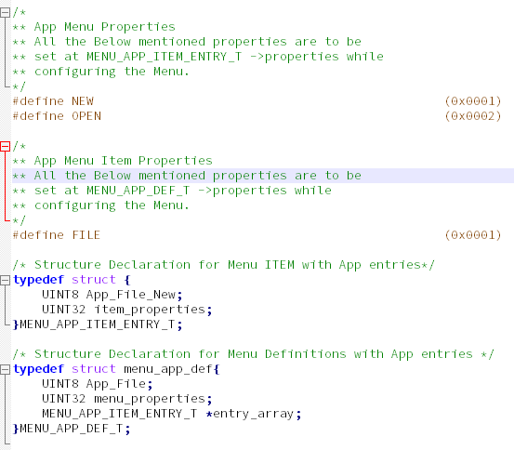

Menu Button to Action Map

Please find the below settings
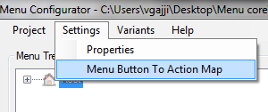
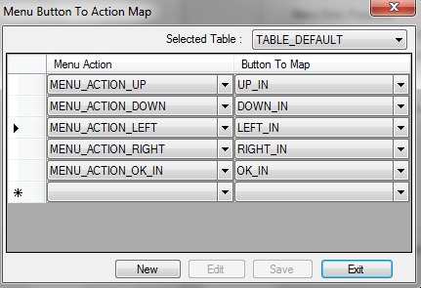
By using this user can create multiple menu button map action tables and the corresponding table id can be updated for each menu. This table index is added as one of the element in MENU_DEF_T structure. Using table index of the menu, menu core will decide which table it needs to use for the corresponding menu. Following table is created by the application by default. This table id will be used if there is no table id is specified for a given menu

MENU_BTN_TO_ACTIONS_MAP_T const hmi_menu_map_actions_1[]=
{
{
MENU_ACTION_UP, UP_IN
},
{
MENU_ACTION_DOWN, DOWN_IN
},
{
MENU_ACTION_LEFT, LEFT_IN
},
{
MENU_ACTION_RIGHT, RIGHT_IN
},
{
MENU_ACTION_OK_IN, OK_IN
}
};

Hmi_menu_def_n.inc file contains the number of tables (HMI_MENU_TABLE_COUNT) and table indices as MENU_BTN_TABLE_ID_n

Sample Menu configuration with basic settings

- Create a folder exercise1\menu.
- Now run MenuConfigurator executable from the following path \ui.core.iceapple.doc\menu.core.01\menu_configurator_tool\MenuConfigurator.exe.
- Click on Project->New to create new configuration.
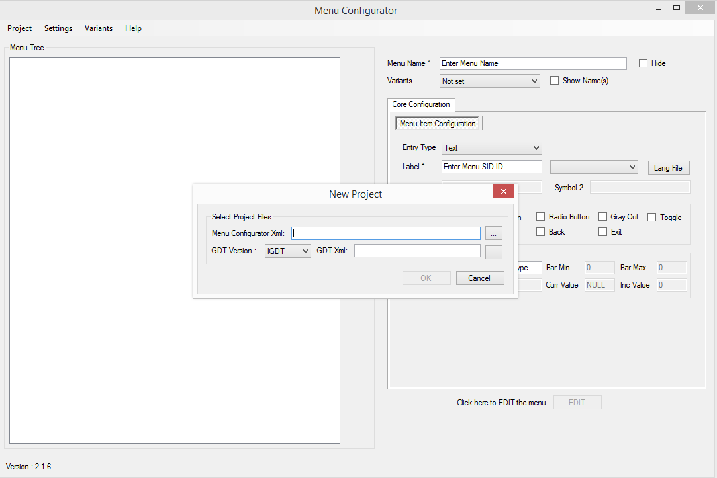

- Give the proper name for Menu configurator Xml
- Select the GDT xml from the exercise1\graphics folder and then select OK. GDT xml file is used to validate the screens and its priorities.
- New project will be created with default settings.

Application Configuration

After creating new project, we need to configure the application specific settings. To do that, click on Settings->Properties menu. Give unique timer id for ‘Menu Open Timer ID’ and ‘Menu Wait Timer ID’ as shown below.
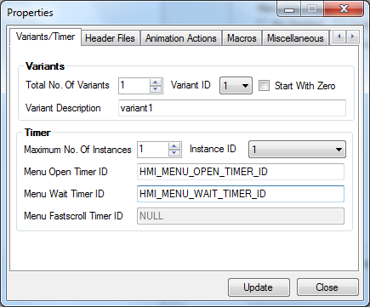

Add Header file

For this sample project, we will disable the fast scroll and enable ‘Item Configuration’ as shown in the below screenshot
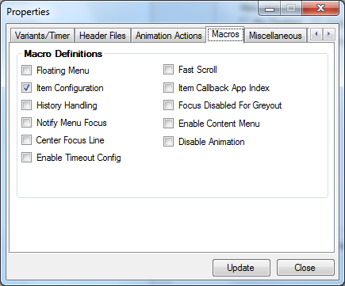

Set the ‘Total Number of Icons’ as ‘1’ for showing icon on the left side of the menu.
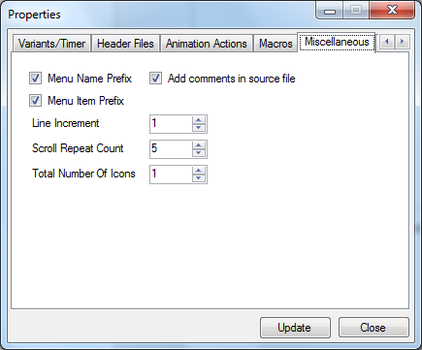
Click on Update and Close to save the application settings.

Adding New Menu
Right click on INSTANCE menu and then select ‘Add’ to add new menu to the project and update the properties on right side of the window. It contains the following configurations
- Menu Item Configuration – Configuration for non-sub menu type
- Menu Configuration – Configuration for sub menu and executable type

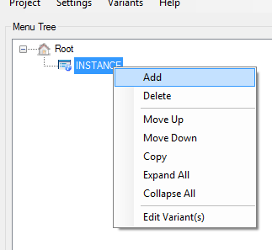

- Set the name as ‘ROOT’. This will be generated as ‘ROOT_MENU_ID’ in the generated code which will be used to communicate with view manager
- Change the entry type as ‘Sub Menu’. This will allow us to configure the next level of the menu
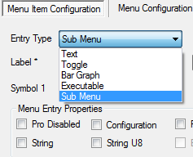
- Next we need to give the label for the menu. Provide the SID as you entered in the SID_Language_Table
TxtID_1_13 | Menu | Menu | Menu

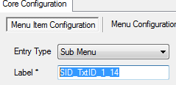

- Next move the ‘Menu Configuration’ tab to provide Sub menu related configurations
- Select the screen id from the list of available screens in the drop down menu. These screens are populated from the given GDT xml file. For this ‘ROOT’ menu, select the ‘GFX_SCR_ROOT_MENU’ as screen id. This screen id is corresponding to ‘scr_root_menu’ screen in GDT
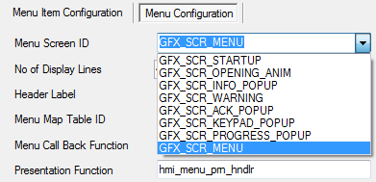
- Set the No. of Display Lines as 4. This is to set the maximum number of displayed lines allowed for this screen.
- Then set timeout value to close the menu after the timeout is expired. To achieve this timeout, we need to call ‘hmi_menu_logic_open_timer_timeout’ function in the timer expired event.
- Update the menu presentation function as shown in below image.
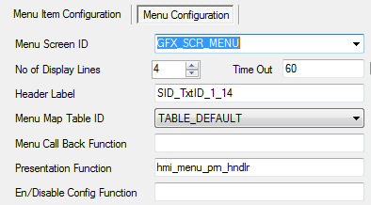

This function should be defined in application files. Refer hmi_menu_presentation.c for sample presentation handler. Click on ‘Save’ button to save the configuration.
Now ‘ROOT’ menu added in the left side of the tree view.
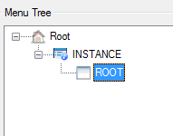
Now we have created the sample menu configuration. After this, we need to set the variants for the menu items. In this sample project, we are having only one variant. Follow the below steps to set the variant for the menu
- Right click on the root menu to display the context menu
- Click on the ‘Edit Variant(s)’ option
- Set the value as ‘1’ and then click on the ‘OK’ button to save
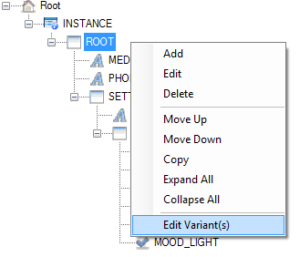
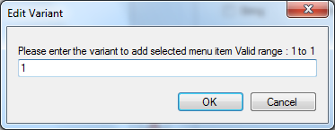

Next step is to generate the code. Click on the ‘Generate Code’ from ‘Project’ menu as shown in below
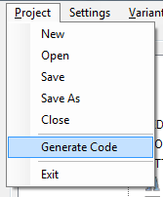

Wait for the code generation complete dialog and then you can verify the generated code inside the menu folder. Following files will be generated from the tool. Ensure the settings which you have configured in the below files captured.
hmi_menu_config_1.inc
hmi_menu_def_1.inc

Message Core

This Message core component provides the functionality for managing application - defined messages and showing them on the display (LCD). Each message belongs to the defined set of message types which are rated according to their severity. In addition, the user (driver) can browse stored messages via the external interfaces available in the device.

Please find the configurator tool
Open Warning_configuration.xls and open the sheet Config_sheet Configuring hard Warnings.
- Configure the first warning with S No as 1. Variant as Common. Column “Message ID” as HARD_WARNING_ID.
- Column “U08SIF_GET_DATACheckActiveCondition” as “hmi_msg_warn_get_status”.
- Column “ConditionQualifier” as “HARD_WARNING_ID_INDEX”.
- Column “U08SIF_GET_DATAMsgEventCallbackFunction” as “hmi_msg_app_wrn_notify_status_cb”
- Column “CallbackEventQualifier” as “MSG_EVENT_SHOW | MSG_EVENT_ACKNOWLEDGED | MSG_EVENT_HIDDEN | MSG_EVENT_INACTIVE “
- Column “Display TimeOut” as “NO_TIMEOUT”.
- Column “Hold TimeOut” as “NO_TIMEOUT”.
- Column “eMessageCategory” as “mcHardWarning”.
- Column “Priority” as 1.
- Column “Options” as “HARD_WARNING_OPTIONS”.
- Column “ActiveStates” as “MSG_IGNRUN”.
- Column “Chimes” as “UI_WARNING_CHIME_NONE”.
- Column “Header” and “Header_SID” as 0. If required headers can be designed in GDT tool and can be mentioned here.
- Column “Line1_Text_ID” as “GFX_TXT_HARDWRNG” generated from GDT tool in file “hmi_gfx_mgr02_cfg.h”.
- Column “Line_1_SID” as “SID_HARD_WRNG” generated from language tool in file hmi_language_identifiers.h.
- Column “Line2_Text_ID” and “Line_2_SID” as 0. Column “Line3_Text_ID” and “Line_3_SID” as 0
- Column “Popup ID” as “L0_WARNING_POPUP_ID” the value of popup ID generated in “hmi_popup_core_if.h”.
Make sure the below files has to be generated after code generation
  - hmi_msgDefinition.inc
  - hmi_msgPresentation.inc

Language Core

Path:
..\..\ui.core.iceapple.doc\language.core.01\language_encoder_tool\ LanguageEncoder.exe

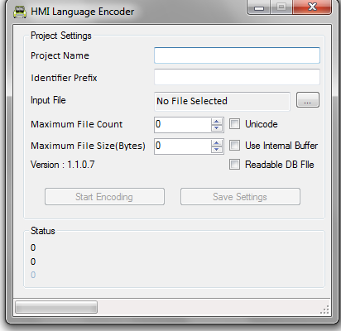

Settings: please find the section 3.3 and more information about Language support find the section 4.9 & 4.10 in GDT User manual

Animation Core
Please find the section 4.8 in GDT User manual

View Manager
View manager operates in a statically generated configuration. Each window is statically defined at compile time. Further on, the window will be termed as a View in view manager context. Each view in the view manager has a priority associated with it, and it determines what the order of rendering is. A priority of 0 corresponds to a view that is bottommost order, 1 corresponds to view above the bottommost. A view with the largest priority value will be topmost on the display and which will also hold the user focus.

View Manager is responsible for
  - Displaying the screens as priority wise
  - Handles the screen Event / Focus / Presentation handler functions
  - Add/remove with or without performing an animation
  - Focus Notifications
  - Got focus : when a view regains top priority
  - Lost focus : when a view is overridden by another high priority view
  - Animation Started
  - Animation Completed
  - Deactivated : view is removed
  - Deactivation pending : Deactivation request accepted but pending due to removal animation in progress
  - Button event routing
  - Presentation scheduling for active views
For better understanding please find the below screen

